## Traceability

Traceability reports allow you to perform coverage analysis by viewing relationships between requirements and related items in a project.

### Test Case Backward Traceability

A Test Case Backwards Traceability report displays the relationships between the selected test cases and the requirements those test cases were generated for. This is essentially the same report as a Test Case Detail report using the TestCaseBackwardsTraceabilityReport.xslt stylesheet. However the Traceability report allows filtering on the requirements as well as the test cases.

As each test case is created, it should be identified as belonging to the requirement specification. This ensures that you can quickly determine exactly what test cases belong to each specification, which provides traceability. This report is useful for visualizing the relationships between the test cases and their parent requirements and for identifying test cases that were never associated with a requirement.

This report answers such questions as:

* Are there any test cases that are not testing a specific requirement?
* What requirements are the test cases testing?
* Are any test cases testing multiple requirements?

This report is only valid for test cases and requirements and requires both a TestTrack TCM and TestTrack RM license.

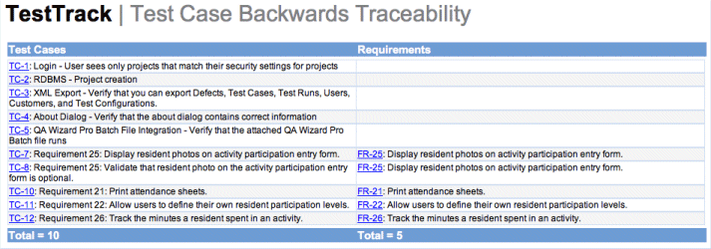

#### Running the Report

This report requires a test case. This report can be created in the report detail window or ran from the test case list window.

#### X-Axis

The X-Axis displays a column for the selected Test Cases and a column for the Requirements that were linked to those test cases.

#### Y-Axis

* **Test Cases -** The Y-Axis displays a row for each test case showing the test case tag and summary.
* **Requirements -** For each test case row there may be one or more rows showing the requirements that are being tested by the test case.

**Requirement Forward Traceability**

A Requirement Forward Traceability report displays the relationships between the selected requirements, the test cases associated with those requirements, and any defects reported for these test cases. This is essentially the same report as a Requirement Detail report using the RequirementForwardTraceability.xslt stylesheet. However the Traceability report allows filtering on the defects and test cases as well as the requirements.

Management uses this report to make sure that test cases have been created for all requirements and to identify requirements that are creating the most defects. Once testing starts, it is important to identify the defects that were created based on the specific test case that failed and then link the defects back to the requirement. This allows you to determine which requirements spawn the most defects.

This report answers such questions as:

* Are all requirements being covered by test cases?
* Do any requirements have multiple test cases?
* What requirements have generated defects?
* Are any requirements creating too many defects?

This report is requires a TestTrack RM license to be ran and will only display all data when a TestTrack TCM and TestTrack Pro license is also used.



#### Running the Report

This report must be run against a requirement. This report can be created in the report detail window or ran from the requirement list window.

#### X-Axis

The X-Axis displays a column for the selected requirements, a column for the test cases that were linked to those requirements, and then a column for the defects that were linked back to the test cases.

#### Y-Axis

* **Requirements -** The Y-Axis displays a row for each requirements showing the requirement tag and summary.
* **Test Cases -** For each requirement row there may be one or more rows showing the test cases that are linked to the requirement.
* **Defects –** For each test case row there may be one or more rows showing the defects that are linked to the test case.

**Requirement Test Case Coverage**

A Requirement Test Case Coverage report displays detailed status information about the test cases generated for the selected requirements. This report requires a TestTrack TCM license in order to view the test cases.

This report is useful for viewing the test cases and their steps for all selected requirements.

This report answers such questions as:

* What is the test plan for a requirement?
* What are the steps being tested for a requirement?

This report is requires a TestTrack RM license to be ran and will only display all data when a TestTrack TCM license is also used.



#### Running the Report

This report must be run against a requirement. This report can be created in the report detail window or ran from the requirement list window.

Test steps for the test cases can be hidden or shown individual or by all test cases.

**Requirement Test Run Coverage**

A Requirement Test Run Coverage report displays detailed status information about the test runs generated for all test cases associated with the selected requirements. This report requires a TestTrack TCM license in order to view the test runs.

This report is useful for viewing the status of the test runs associated with requirements.

This report answers such questions as:

* What is the percent completion status for the test runs for each requirement?
* What is the percent completion status for the test runs for this phase of testing?
* How many test runs have failed for each requirement?

This report is requires a TestTrack RM license to be ran and will only display all data when a TestTrack TCM license is also used.

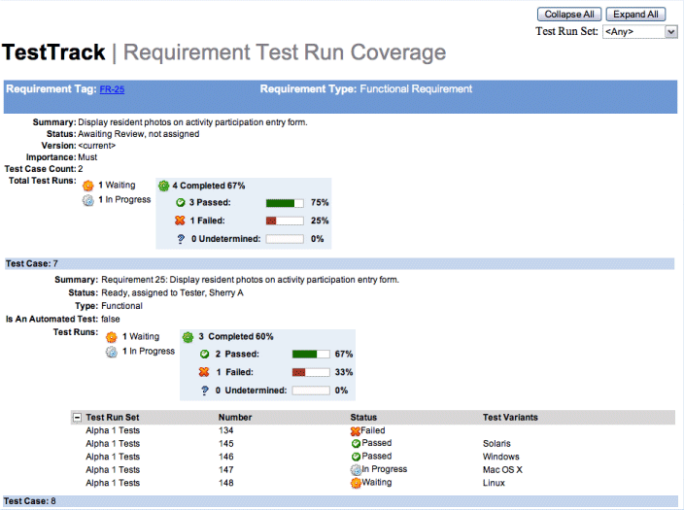

#### Running the Report

This report must be run against a requirement. This report can be created in the report detail window or ran from the requirement list window.

The report can be adjusted to show the results from only specific run sets. The list of run sets for each test case can be hidden or shown individually or by all.

**Requirement Document Forward Traceability**

A Requirement Document Forward Traceability report displays the relationships between requirement within the selected documents, the test cases associated with those requirement and any defects reported for these test cases. This is essentially the same report as a Requirement Document Detail report using the RequirementDocumentForwardTraceabilityReport.xslt stylesheet. However the Traceability report allows filtering on the defects, test cases, and requirements, as well as the requirement documents.

This report answers such questions as:

* Have all of the business requirements been decomposed into functional requirements?
* Have all of the user stories been decomposed into tasks?
* Are all requirements, stories, or tasks covered by test cases?
* What business requirement or story is generating the most defects?

This report is requires a TestTrack RM license to be ran and will only display all data when a TestTrack Pro and TestTrack TCM license is also used.



#### Running the Report

This report requires a requirement document. This report can be created in the report detail window or ran from the requirement document list window.

#### X-Axis

The X-Axis displays a column for the requirement types in the order as shown in the Requirement Types administration dialog, a column for the test cases that were linked to those requirements, and then a column for the defects that were linked back to the test cases.

#### Y-Axis

* **Requirements -** The Y-Axis displays a row for each requirements showing the requirement tag and summary. For each requirement the next requirement column may contain one or more rows showing the requirements that were children to the requirements in the specification document.
* **Test Cases -** For each requirement row there may be one or more rows showing the test cases that are linked to the requirement.
* **Defects –** For each test case row there may be one or more rows showing the defects that are linked to the test case.